Central Carolina Academy
Board of Directors Meeting Agenda
January 19, 2024 at 12:30pm

Call to Order (12:30 PM)

Reading of the Central Carolina Academy Mission Statement (12:31 PM)
Central Carolina Academy will establish and maintain a challenging learning environment that respects the individual learners and prepares students to succeed in a globally competitive society.

Ethics Statement (12:32 PM)
Board members are reminded that it is our duty to avoid conflicts of interest and the appearance of conflicts of interest as we handle the work of this Board.
Does any member of the Board know of any conflict of interest or any appearance of conflict with respect to any matters coming before us at this meeting? If so, please state them for the record.
If during the course of the meeting you become aware of an actual or apparent conflict of interest, please bring the matter to the attention of the Board President. It will then be your duty to abstain from participating in discussion on the matter and from voting on the matter.
Is there a report of conflict at this time?

Public Comment
Persons who want to publicly address the Board must register to do so by emailing the Board President (dsloan@ccasanford.org) no later than 48 hours prior to the meeting. A maximum of two minutes is granted to each speaker, with a total of 10 minutes designated at the beginning of the meeting for all comments.

Consent Agenda (for action) (12:35 PM)
- Approval of today’s meeting agenda
- Approval of December 15, 2023 meeting minutes
- Approval of Approval of Financials

Central Services Team (CST) Report (12:37 PM)
- Facilities and Operations Report (Clint Fields)
- Admissions - Application Report (Julia-Brent Milholen)

New Business (12:42 PM)
- Introduction and Presentation of Board member Slate (for action)
- Personnel Agenda (for action)

Old Business (12:50 PM)
- January 2024 Required NC Session Law 2023-106 Parental Notifications (for action)
- Board committee work

Adjourn (1:00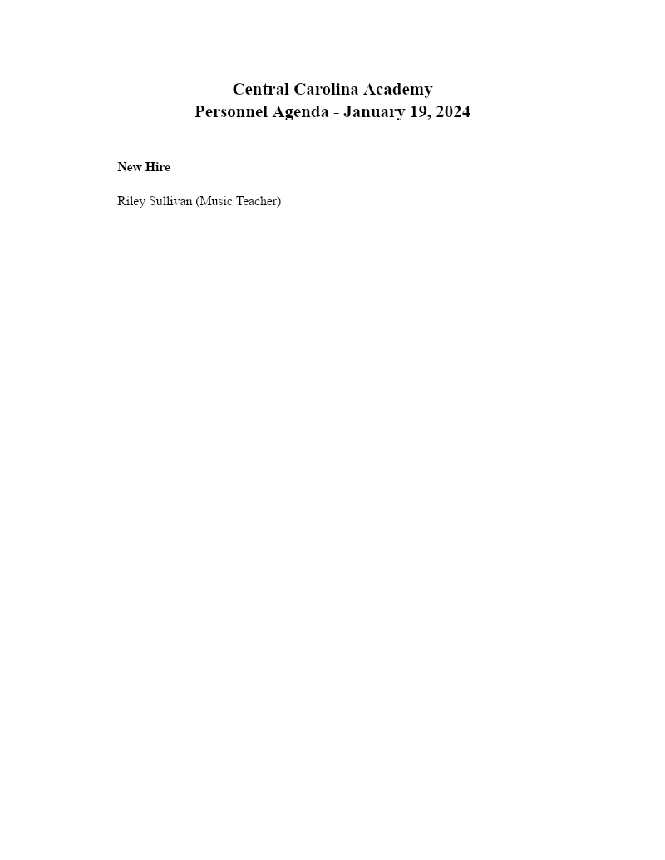 PM)

